* **Hello World RESTful Web Service**

**HelloController**

package com.cognizant.spring_learn;

import org.slf4j.Logger;

import org.slf4j.LoggerFactory;

import org.springframework.web.bind.annotation.GetMapping;

import org.springframework.web.bind.annotation.RestController;

@RestController

public class HelloController {

private static final Logger LOGGER = LoggerFactory.getLogger(HelloController.class);

@GetMapping("/hello")

public String sayHello() {

LOGGER.info("START - sayHello()");

String message = "Hello World!!";

LOGGER.info("END - sayHello()");

return message;

}

}

**SpringlearnApplication.java**

package com.cognizant.spring_learn;

import org.springframework.boot.SpringApplication;

import org.springframework.boot.autoconfigure.SpringBootApplication;

@SpringBootApplication

public class SpringlearnApplication {

public static void main(String[] args) {

SpringApplication.run(SpringlearnApplication.class, args);

}

}

**Application.properties**

server.port=8083

logging.level.root=INFO

logging.level.com.cognizant.spring_learn=INFO

**pom.xml**

<project xmlns="http://maven.apache.org/POM/4.0.0"

xmlns:xsi="http://www.w3.org/2001/XMLSchema-instance"

xsi:schemaLocation="http://maven.apache.org/POM/4.0.0

http://maven.apache.org/xsd/maven-4.0.0.xsd">

<modelVersion>4.0.0</modelVersion>

<groupId>com.cognizant.spring-learn</groupId>

<artifactId>spring-learn</artifactId>

<version>0.0.1-SNAPSHOT</version>

<packaging>jar</packaging>

<name>spring-learn</name>

<parent>

<groupId>org.springframework.boot</groupId>

<artifactId>spring-boot-starter-parent</artifactId>

<version>3.2.0</version> <!-- Use latest stable if available -->

<relativePath/> <!-- lookup parent from repository -->

</parent>

<properties>

<java.version>17</java.version> <!-- Use 11 or 17 -->

</properties>

<dependencies>

<!-- Spring Boot Web Starter -->

<dependency>

<groupId>org.springframework.boot</groupId>

<artifactId>spring-boot-starter-web</artifactId>

</dependency>

<!-- Logging (optional, included by default) -->

<dependency>

<groupId>org.slf4j</groupId>

<artifactId>slf4j-api</artifactId>

</dependency>

<!-- For Spring Boot App execution -->

<dependency>

<groupId>org.springframework.boot</groupId>

<artifactId>spring-boot-starter</artifactId>

</dependency>

<!-- For testing (optional) -->

<dependency>

<groupId>org.springframework.boot</groupId>

<artifactId>spring-boot-starter-test</artifactId>

<scope>test</scope>

</dependency>

</dependencies>

<build>

<plugins>

<!-- Spring Boot Maven Plugin -->

<plugin>

<groupId>org.springframework.boot</groupId>

<artifactId>spring-boot-maven-plugin</artifactId>

<version>3.2.0</version>

</plugin>

</plugins>

</build>

</project>

**Output**

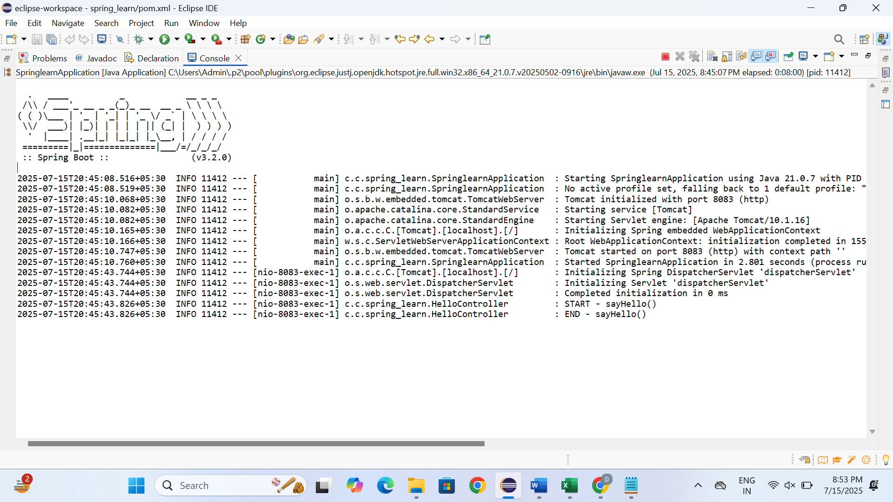

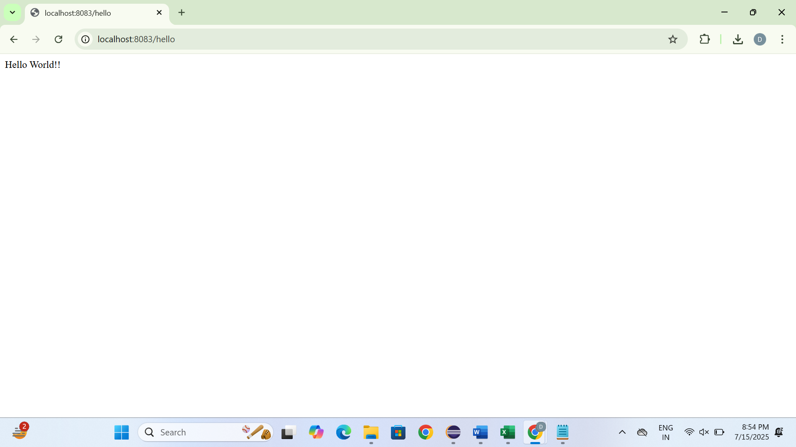

* **REST - Country Web Service**

**Country.java**

package com.cognizant.spring_learn;

public class country {

private String code;

private String name;

public country() {}

public country(String code, String name) {

this.code = code;

this.name = name;

}

public String getCode() {

return code;

}

public void setCode(String code) {

this.code = code;

}

public String getName() {

return name;

}

public void setName(String name) {

this.name = name;

}

}

**CountryController.java**

package com.cognizant.spring_learn;

import com.cognizant.spring_learn.country;

import org.slf4j.Logger;

import org.slf4j.LoggerFactory;

import org.springframework.context.ApplicationContext;

import org.springframework.context.support.ClassPathXmlApplicationContext;

import org.springframework.web.bind.annotation.RequestMapping;

import org.springframework.web.bind.annotation.RestController;

@RestController

public class CountryController {

private static final Logger *LOGGER* = LoggerFactory.*getLogger*(CountryController.class);

@RequestMapping("/country")

public country getCountryIndia() {

*LOGGER*.info("START - getCountryIndia()");

ApplicationContext context = new ClassPathXmlApplicationContext("spring.xml");

country Country = (country) context.getBean("in");

*LOGGER*.info("END - getCountryIndia()");

return Country;

}

}

**SpringlearnApplication.java**

package com.cognizant.spring_learn;

import org.springframework.boot.SpringApplication;

import org.springframework.boot.autoconfigure.SpringBootApplication;

@SpringBootApplication

public class SpringlearnApplication {

public static void main(String[] args) {

SpringApplication.*run*(SpringlearnApplication.class, args);

}

}

**Spring.xml**

<?xml version="1.0" encoding="UTF-8"?>

<beans xmlns="http://www.springframework.org/schema/beans"

xmlns:xsi="http://www.w3.org/2001/XMLSchema-instance"

xsi:schemaLocation="http://www.springframework.org/schema/beans

https://www.springframework.org/schema/beans/spring-beans.xsd">

<bean id="in" class="com.cognizant.spring_learn.country">

<property name="code" value="IN" />

<property name="name" value="India" />

</bean>

</beans>

**Application.properties**

# Set the port to 8083 as required

server.port=8083

# Optional: Set logging level

logging.level.root=INFO

logging.level.com.cognizant.spring_learn=INFO

**output**

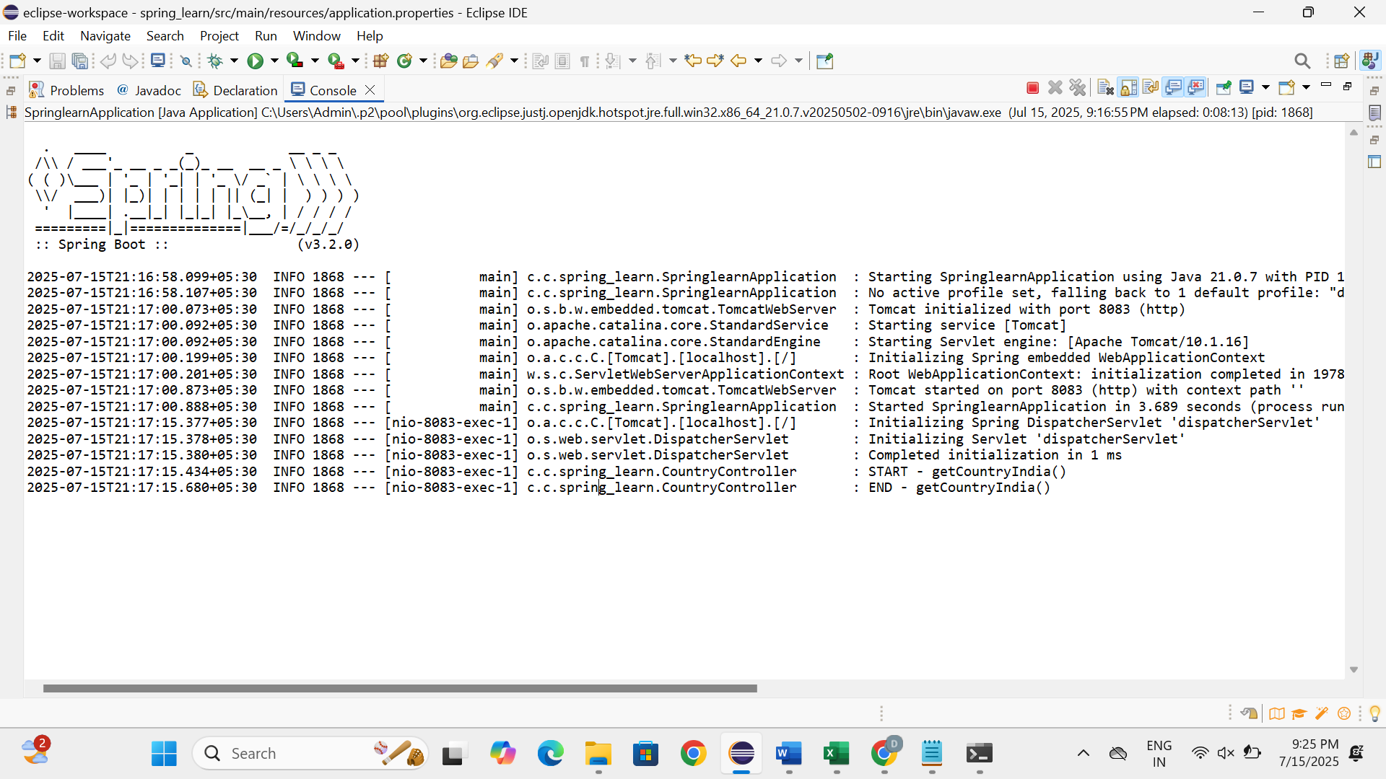

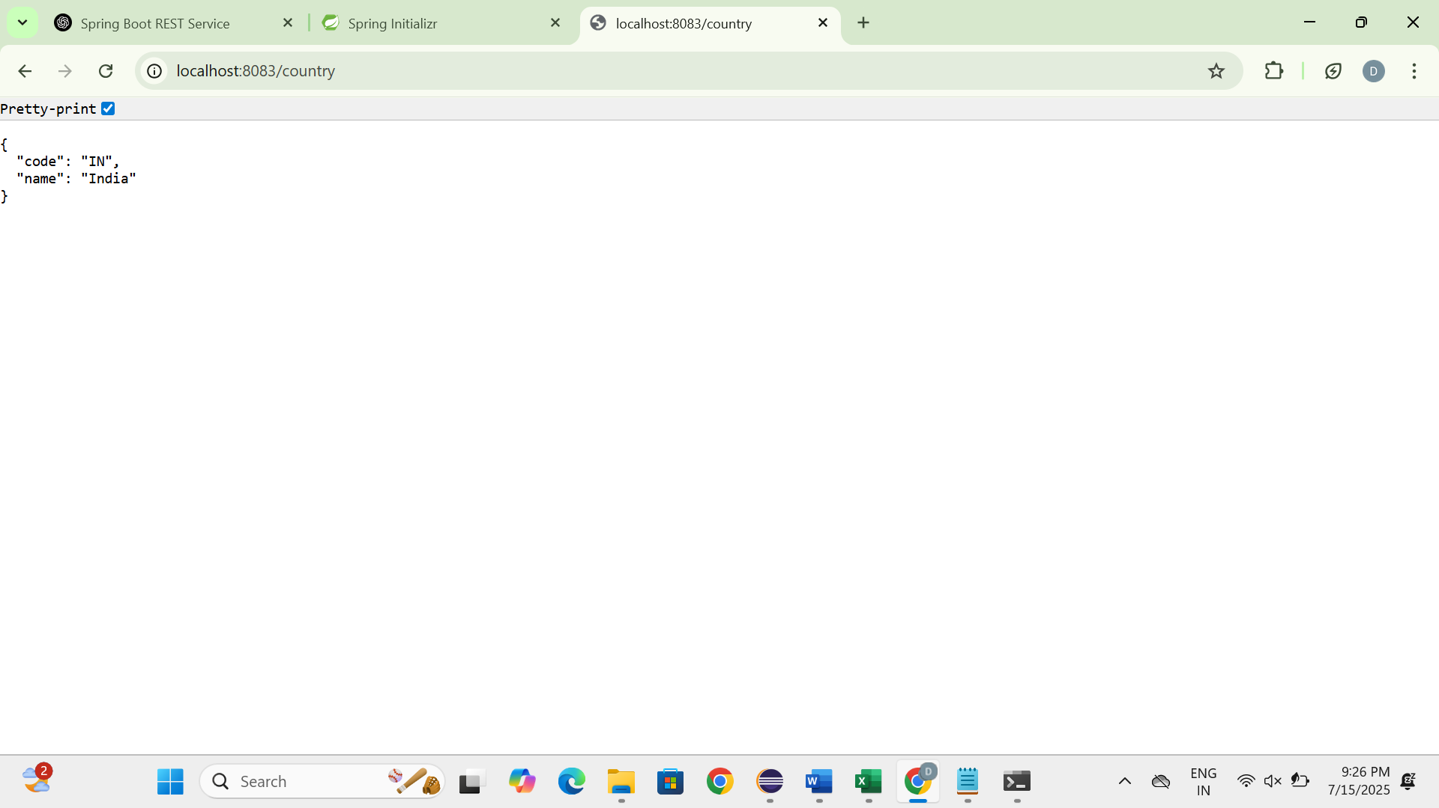

**REST - Get country based on country code**

**country.java**

package com.cognizant.spring_learn;

public class country {

private String code;

private String name;

// Getters and Setters

public String getCode() {

return code;

}

public void setCode(String code) {

this.code = code.toUpperCase(); // Optional: Normalize to uppercase

}

public String getName() {

return name;

}

public void setName(String name) {

this.name = name;

}

}

**CountryController.java**

package com.cognizant.spring_learn;

import com.cognizant.spring_learn.country;

import com.cognizant.spring_learn.CountryService;

import org.springframework.beans.factory.annotation.Autowired;

import org.springframework.web.bind.annotation.*;

@RestController

public class CountryController {

@Autowired

private CountryService countryService;

@GetMapping("/countries/{code}")

public country getCountry(@PathVariable String code) {

return countryService.getCountry(code);

}

}

**Country.xml**

<?xml version="1.0" encoding="UTF-8"?>

<beans xmlns="http://www.springframework.org/schema/beans"

xmlns:xsi="http://www.w3.org/2001/XMLSchema-instance"

xsi:schemaLocation="http://www.springframework.org/schema/beans

https://www.springframework.org/schema/beans/spring-beans.xsd">

<bean id="countryList" class="java.util.ArrayList">

<constructor-arg>

<list>

<bean class="com.cognizant.spring_learn.country">

<property name="code" value="IN"/>

<property name="name" value="India"/>

</bean>

<bean class="com.cognizant.spring_learn.country">

<property name="code" value="US"/>

<property name="name" value="United States"/>

</bean>

<!-- Add more countries as needed -->

</list>

</constructor-arg>

</bean>

</beans>

**CountryService**

package com.cognizant.spring_learn;

import com.cognizant.spring_learn.country;

import org.springframework.context.ApplicationContext;

import org.springframework.context.support.ClassPathXmlApplicationContext;

import org.springframework.stereotype.Service;

import java.util.List;

@Service

public class CountryService {

public country getCountry(String code) {

ApplicationContext context = new ClassPathXmlApplicationContext("country.xml");

List<country> countryList = (List<country>) context.getBean("countryList");

return countryList.stream()

.filter(c -> c.getCode().equalsIgnoreCase(code))

.findFirst()

.orElse(null); // Or throw a custom CountryNotFoundException

}

}

**SpringlearnApplication.java**

package com.cognizant.spring_learn;

import org.springframework.boot.SpringApplication;

import org.springframework.boot.autoconfigure.SpringBootApplication;

@SpringBootApplication

public class SpringlearnApplication {

public static void main(String[] args) {

SpringApplication.*run*(SpringlearnApplication.class, args);

}

}

**Pom.xml**

<project xmlns="http://maven.apache.org/POM/4.0.0"

xmlns:xsi="http://www.w3.org/2001/XMLSchema-instance"

xsi:schemaLocation="http://maven.apache.org/POM/4.0.0

http://maven.apache.org/xsd/maven-4.0.0.xsd">

<modelVersion>4.0.0</modelVersion>

<groupId>com.cognizant.spring-learn</groupId>

<artifactId>spring-learn</artifactId>

<version>0.0.1-SNAPSHOT</version>

<packaging>jar</packaging>

<name>spring-learn</name>

<parent>

<groupId>org.springframework.boot</groupId>

<artifactId>spring-boot-starter-parent</artifactId>

<version>3.2.0</version> <!-- Use latest stable if available -->

<relativePath/> <!-- lookup parent from repository -->

</parent>

<properties>

<java.version>17</java.version> <!-- Use 11 or 17 -->

</properties>

<dependencies>

<!-- Spring Boot Web Starter -->

<dependency>

<groupId>org.springframework.boot</groupId>

<artifactId>spring-boot-starter-web</artifactId>

</dependency>

<!-- Logging (optional, included by default) -->

<dependency>

<groupId>org.slf4j</groupId>

<artifactId>slf4j-api</artifactId>

</dependency>

<!-- For Spring Boot App execution -->

<dependency>

<groupId>org.springframework.boot</groupId>

<artifactId>spring-boot-starter</artifactId>

</dependency>

<!-- For testing (optional) -->

<dependency>

<groupId>org.springframework.boot</groupId>

<artifactId>spring-boot-starter-test</artifactId>

<scope>test</scope>

</dependency>

</dependencies>

<build>

<plugins>

<!-- Spring Boot Maven Plugin -->

<plugin>

<groupId>org.springframework.boot</groupId>

<artifactId>spring-boot-maven-plugin</artifactId>

<version>3.2.0</version>

</plugin>

</plugins>

</build>

</project>

**Output**

